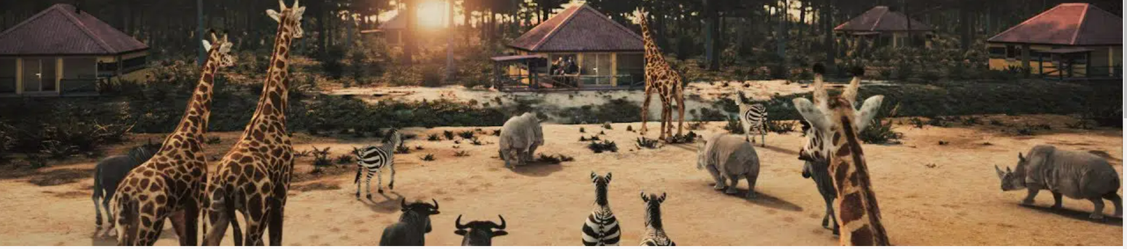

SAFARI **PARK**

Welcome to the Safari Club. This site will show you different animals. Do you know these animals? If you want to hear the Lion scream

CLICK THE LION TO LEARN MORE

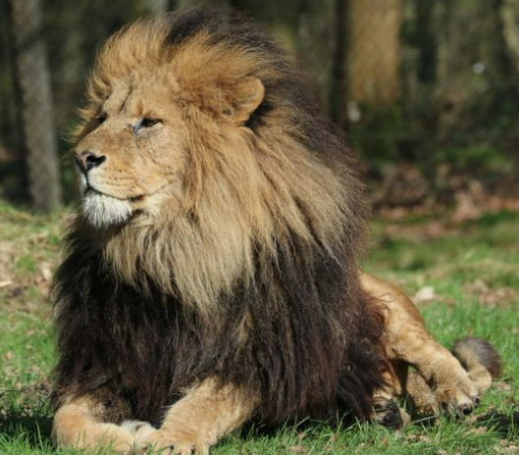

* Image Gallery
* Diet Information
* Mating and Reproduction Information
* Animal Communications
* Miscellaneous Interesting Facts
* Animal Anatomy and Biology
* Animal Behavior
* Popular Culture